7. create and normalize a flat CSV dataset in Microsoft Power BI Desktop by creating dimension and fact tables using Power Query, replacing text fields with keys, and exporting the normalized result
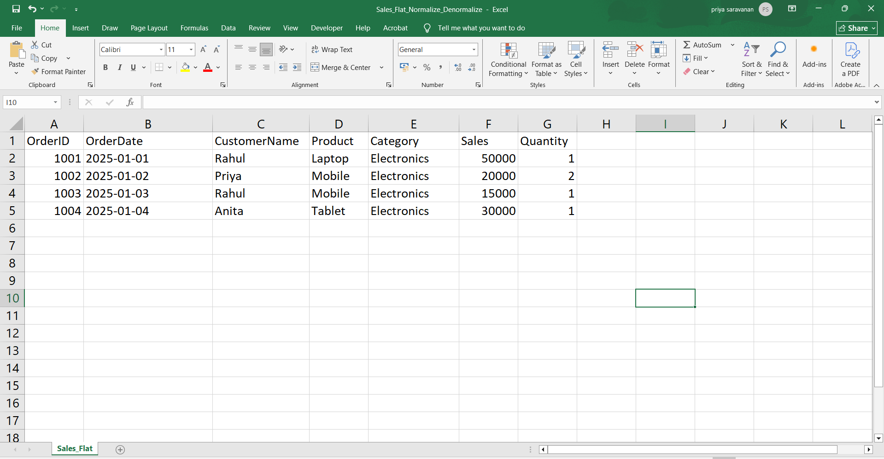
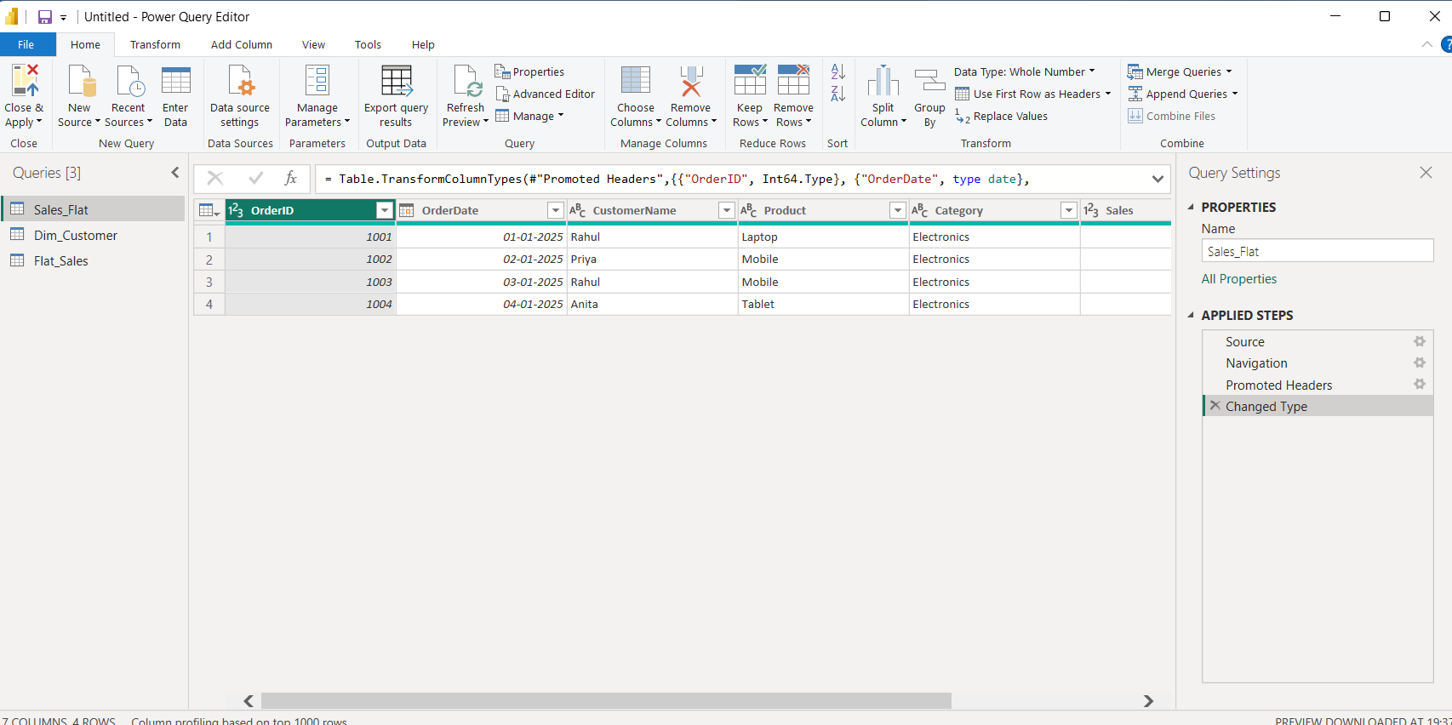
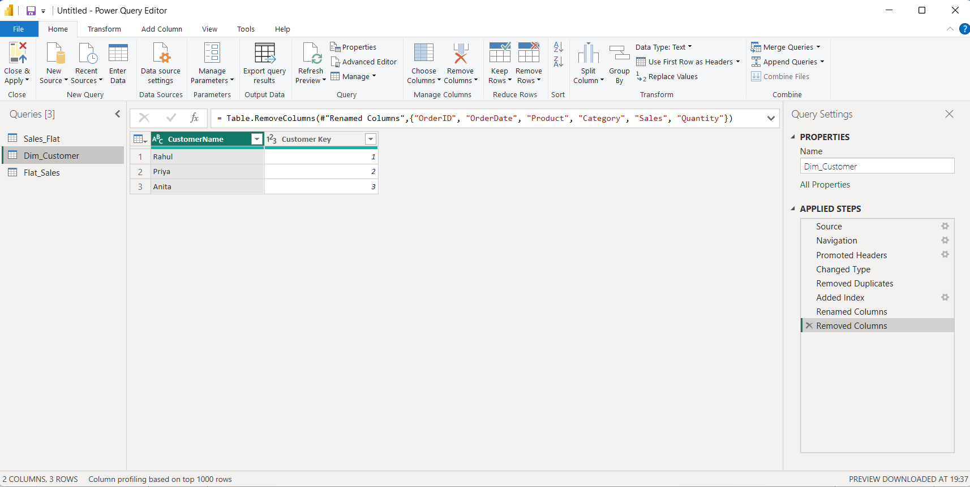
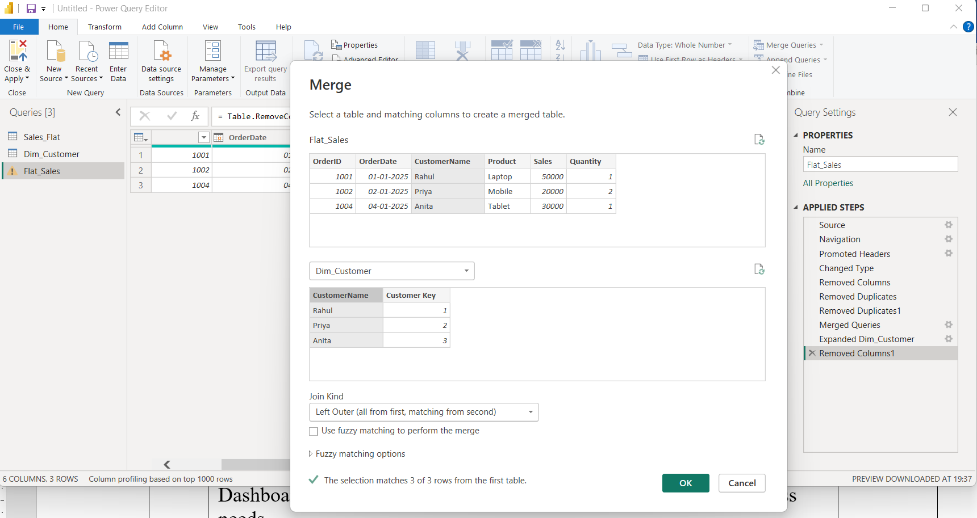

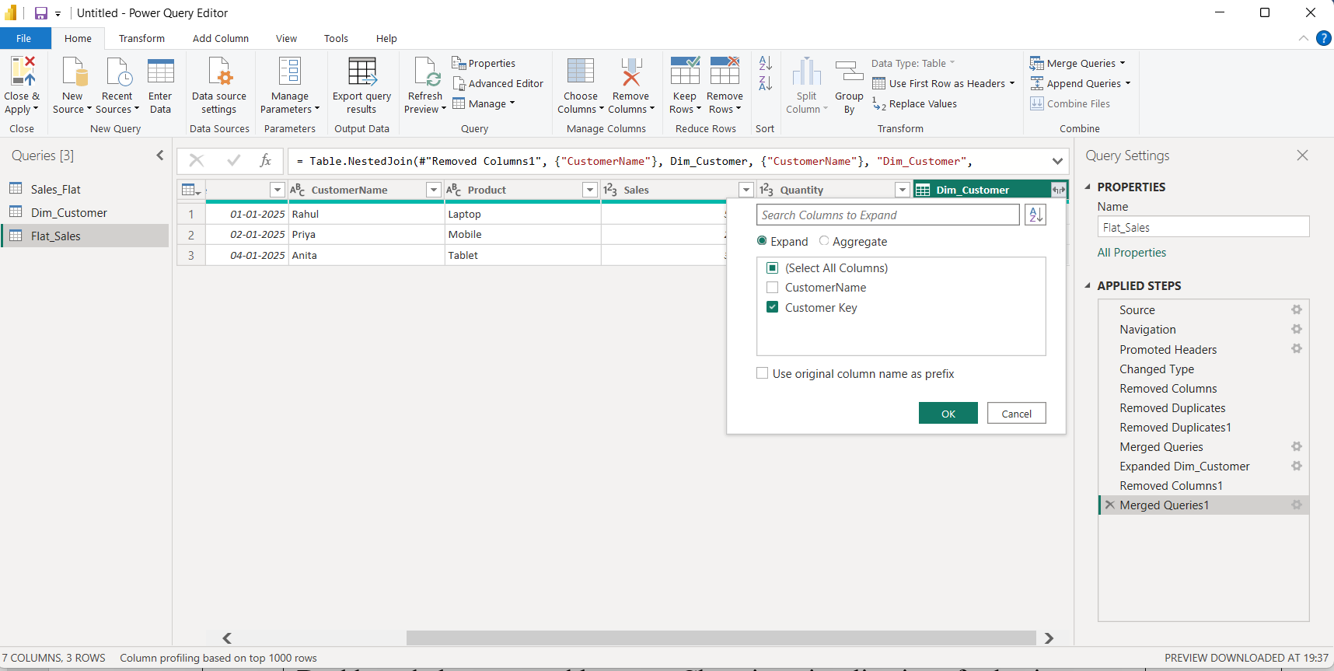
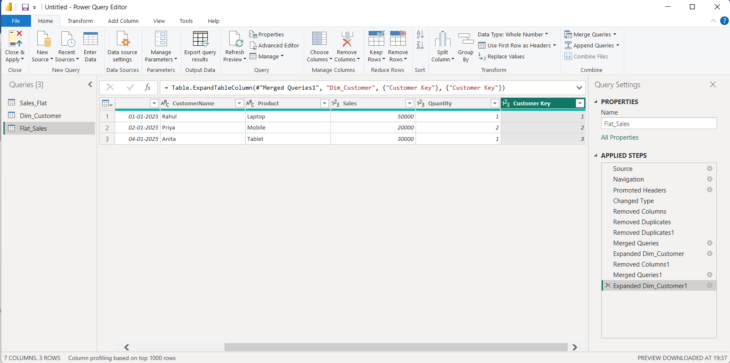

🔹 PART A: NORMALIZE (FROM THE SAME FILE)

🛠 Step 1: Load the CSV
- Open Power BI Desktop
- Home → Get Data → Text/CSV
- Select Sales_Flat.csv
- Click Transform Data
➡️ Power Query Editor opens
➡️ One query: Sales_Flat

🧱 Step 2: Create Dimension Tables (From Same File)
✅ Step 2.1: Create Dim_Customer
- Right-click Sales_Flat → Duplicate
- Rename to Dim_Customer
- Keep only:
  - CustomerName
- Home → Remove Rows → Remove Duplicates
- Add Column → Index Column → From 1
- Rename index to CustomerKey
✔ Customer dimension created

🧮 Step 2: Create Fact_Sales
- Right-click Sales_Flat → Duplicate
- Rename → Fact_Sales
- Keep columns:
  - OrderID
  - OrderDate
  - CustomerName
  - Product
  - Sales
  - Quantity

🔗 Step 4: Replace Text with Keys (Normalization)
🔹 Replace CustomerName
- Select Fact_Sales
- Home → Merge Queries
- Merge with Dim_Customer on CustomerName
- Expand → CustomerKey
- Remove CustomerName
✔ Data is now NORMALIZED
✔ Still using ONE original CSV

📤 Step 6: Export Final Flat Table
- Close & Apply
- Add Table visual
- Click ⋯ → Export data → CSV
🎯 Aim
To normalize a flat CSV dataset in Microsoft Power BI Desktop by creating dimension and fact tables using Power Query, replacing text fields with keys, and exporting the normalized result.

🧭 Algorithm (12 Points)
- Open Microsoft Power BI Desktop.
- Click Home → Get Data → Text/CSV and select Sales_Flat.csv.
- Click Transform Data to open Power Query Editor.
- Right-click Sales_Flat query and choose Duplicate to create a new query.
- Rename the duplicated query as Dim_Customer.
- Keep only the CustomerName column and remove duplicates.
- Add an Index Column (From 1) and rename it as CustomerKey.
- Duplicate Sales_Flat again and rename it as Fact_Sales.
- In Fact_Sales, keep required columns: OrderID, OrderDate, CustomerName, Product, Sales, Quantity.
- Use Merge Queries to join Fact_Sales with Dim_Customer on CustomerName.
- Expand and keep CustomerKey, then remove the CustomerName column to complete normalization.
- Click Close & Apply, create a table visual, and Export the normalized data to CSV.

